August 25, 2022 update

1. Announcement page
   * Working na po ang save and delete button.
   * May problem lang po sa edit button, nasasama po sa pag edit yung div class na nasa loob po ng table data sa table.

* Deleted record 1 and 2

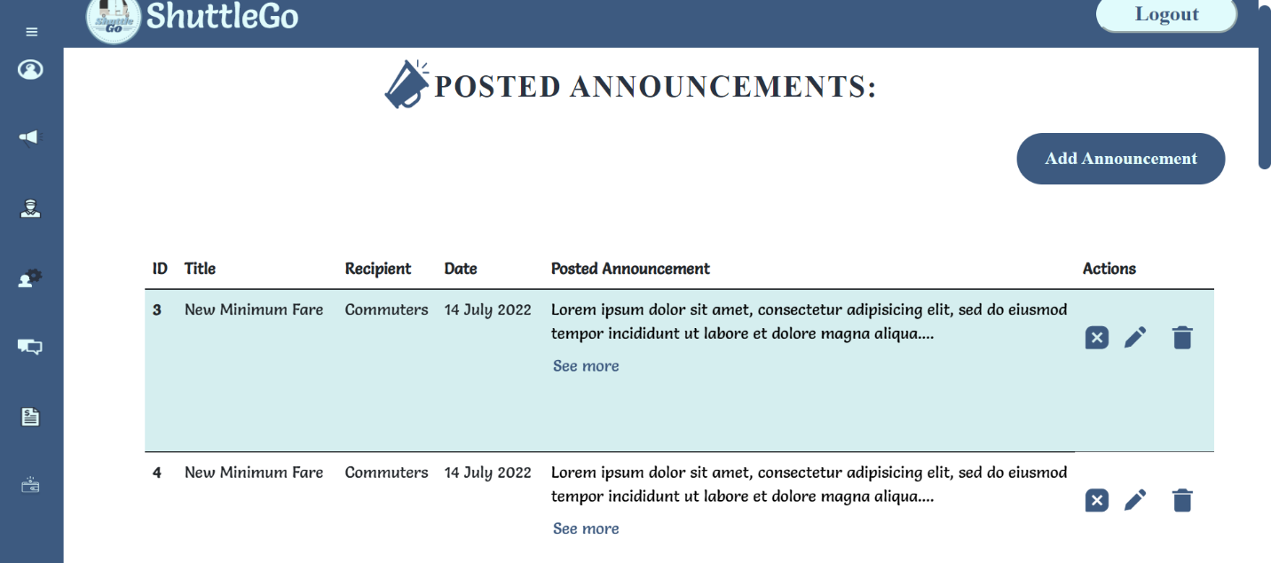

1. Commuters every year page (from the dashboard page)

1. Commuters every month (from the dashboard page)
   * Minor problem po is nasosort agad yung month alphabetically

1. Dashboard
   * Changed the chart’s color and also made it clickable

* Changed the buttons’ name. Hindi po kinaya yung gagawing dropdown yung buttons
* Also added some filters sa table po
* Minor problem po is hindi malagyan ng filter yung tables sa attendance, and driver

* Sample of the filter

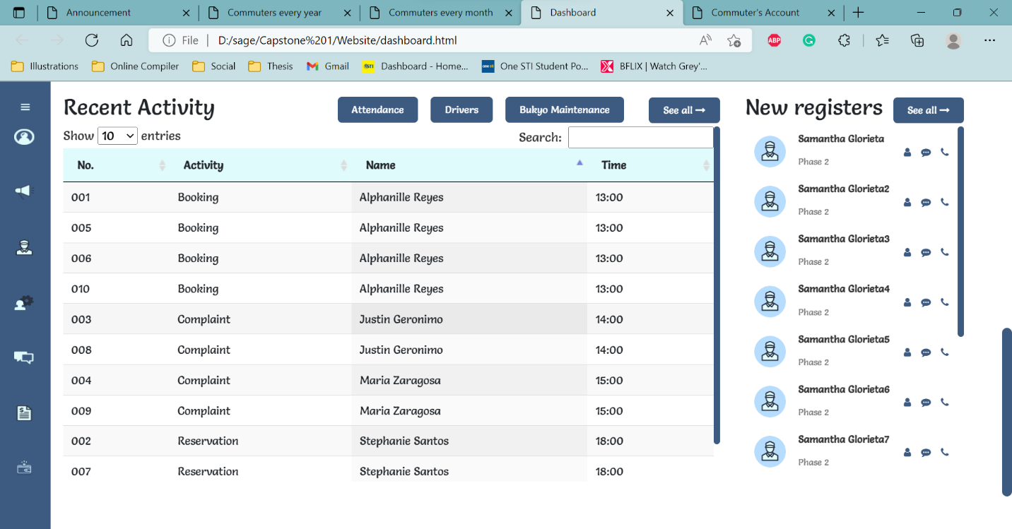

* Attendance table Table

  Description automatically generated
* Drivers table
* Graphical user interface, text, application

  Description automatically generatedBukyo Maintenance table
  + minor problem po is yung top spacing ng table
  + A picture containing table

    Description automatically generatedAnother one po is isang color lang po pwede mapindot ni admin per column

1. View Commuters account new design

